**YOUR NAME (print please)___________________________________________________**

HAND IN THIS WORKSHEET on Fri Jan 20 at start of class.. Please do not write answers on separate, loose sheets.

Use whatever resources you need, including Griffiths, other texts, talking to peers, office hours - whatever you need. In the end, though, like with all homeworks, what you turn in must be your own work, reflecting your own understanding

Note that in general, we grade homeworks for clarity of explanation as much as we do for mere "correctness" of final answer.

Please show your work or explain your reasoning whenever possible.

Integrals:

a)  [ where g(z) is some known, well behaved function of real variable z ]

b) 

Make a quick sketch, in the x-y plane, of the following (two-dimensional) vector function.

Plot enough different vectors to give a feeling for what this field looks like in the x-y plane.

a)  Explain in words what this plot is showing.

b) Consider an r- polar coordinate system defined in the x-y plane as shown. Distance r is the radial distance from the origin, and angle  is the angle measured from the +y direction clockwise to the radial direction, as shown for two points in the diagram. NOTE: this is not the standard convention for polar coordinates. So don’t use a formula from a text, because it probably does not apply here.

Draw the unit vector  at several representative places on the diagram; i.e. in enough places to convince the grader you know how  behaves everywhere.

r

x

y

❑

r

❑

c) Derive a formula for in terms of  and .

a) What is the definition of the divergence of a vector function ? Describe in words what the divergence of a vector is.

b) What is the definition of the curl of a vector function ? Describe in words what the curl of a vector is.

a) Compute the divergence and curl of 



b) What is ?

c) What is Re()?

Given that an electric field in some region of space is given by ,

(where c is a given constant)

a) What are the units of c?

b) What can you tell us about the charge density throughout this region, ρ(x,y,z)? Can you think of a physical situation which has this charge density and electric field?

For each of the four vector fields sketched below....

Which of them have nonzero *divergence* somewhere? ______________

(If the divergence is nonzero *only* at isolated points, which point(s) would that be?)

Which of the following fields have nonzero *curl* somewhere? ___________________

(If the curl is nonzero *only* at isolated points, which point(s) would that be?)

*(A brief explanation of your answers below each figure would be helpful)*

**A. B**

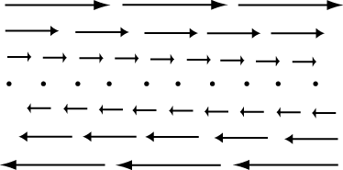 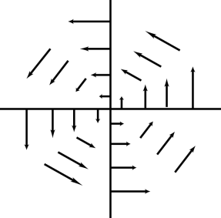

**C. D.**

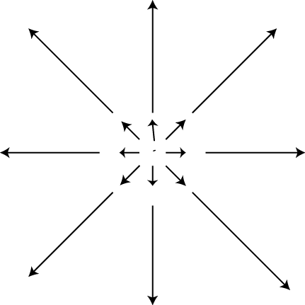 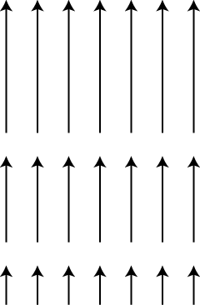

a) What is the definition of the electric field **E**? (Feel free to supplement any equations with words, to make your meaning clear)

b) Gauss' law says: .

Consider a cube of edge length L, filled with a constant, uniform volume charge density . I can image a larger, closed cubical surface neatly surrounding this cube. Can one *use* Gauss' law to compute the value of the electric field at arbitrary points outside the charged cube? (You don't need to do this, just explain if you *could,* and why/why not?)

c) Briefly but clearly, explain the derivation that takes you from Gauss' law written in integral form in (b) to Gauss' law in differential form.